Project Description

The goal of this project is to increase awareness and collaboration of and among agencies, families, and students to better prepare them for successful transition from high school to the next phases of their lives. To accomplish this goal, the team is implementing strategies that increase students' knowledge and skills as they relate to transition resources, career, and job training, access/accommodations, and other essential services.

Project Activities
- Developed a presentation to share information and gain support
- Disseminate an initial survey to parents, students and teachers
- Conduct training for parents and students

Project Timelines
-Project start date: June 2018
-Project completion date: May 2019

About the Team

Team Members
Joe Schmoe | Director | joe@company.com
Jane Doe | Associate Director | jane@company.com
Sally Sue | Outreach Coordinator | sue@company.com

Volunteers
Guy Mann | Parent
Dolly Madison | Parent

Targeted Counties

Our activities will be primarily in the dark pink counties.

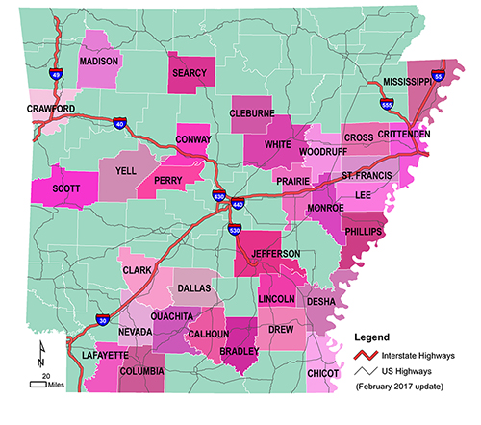

Information about Arkansas

Area / Square Miles: 52,035.48
Population: 2,915,918
School Districts: 239
Counties: 75

FOR MORE INFORMATION ABOUT THIS PROJECT, CLICK HERE.

Thank you to our funders. Visit their page here:

http://exploreaccess.org/disability-as-diversity-postsecondary/long-long-very-long-url-maybe-the-longest-one-ever-created-though-probably-not/

