Refocusing our Approach to Service Delivery
Melanie Thornton, Coordinator of Access and Equity Outreach
University of Arkansas - Partners for Inclusive Communities

Slide 2: Where is your time being spent?
What are 4 things you do in your professional role that take up the most time?

Slide 3: Maxwell Quote
Beware not to get stuck in the thick of thin things. -Neal A. Maxwell

Slide 4: Our Collective List
(to be filled in during session)

Slide 5: Guiding Questions
- How can we reduce our water bailing activities?
- How can we be more proactive and less reactive?

Slide 6: Eisenhower Decision Matrix

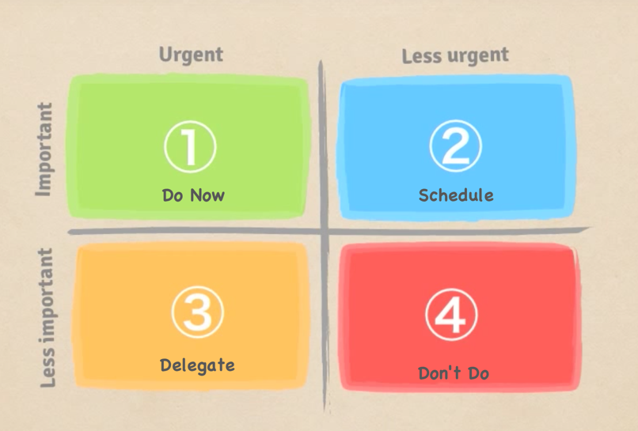

Slide 7: An Equitable Experience?
What are the steps required for the following:
- A nondisabled student to…
- A disabled student to…

Slide 8: Steps in the Process
Nondisabled students
Students with disabilities
(to be filled in during session)

Slide 9: More Guiding Questions
- How can we reduce the steps that are required of students?
- How can we make their experience more similar to that of nondisabled students?

Slide 10: Kari Quote
Disability isn't the problem. What's the problem is convincing others that it's not a problem. - Lais Kari

Slide 11: Crippen Cartoon
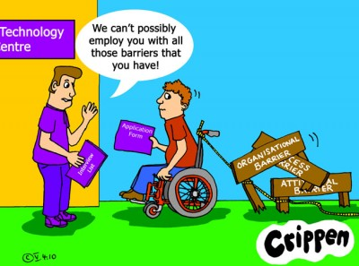

Slide 12: Still More Guiding Questions
- In what ways are we sending the message that disability is the problem?
- How can we change language and practices to relocate the problem elsewhere?

Slide 13: Initial Analysis
- Is our approach moving us toward our vision?
- Is it patching the leak or bailing water?
- How is the experience of disabled students different from or similar to that of nondisabled students?
- What messages does this practice send about disability and students with disabilities?

Slide 14: Further Analysis
- How might this be different?
  - Move us toward our vision?
  - Be more proactive?
  - Be less burdensome for the student?
  - Send fewer problematic messages about disability?

Slide 15: Outreach

Slide 16: Your Elevator Speech
What do you say when someone asks what you do?
Write down what you typically say.

Slide 17: Reflection
- Where is the focus of your speech?
- What message does it send regarding the “problem” of access?
- What language might reinforce societal attitudes about disability?
- How might you shift your elevator speech?

Slide 18: Typical Awareness Programming
- Focus solely on compliance
- Focus on specific disabilities and their implications
- Attempt to simulate disability
- Focus on etiquette or sensitivity

Slide 19: The Problem
- We are including people with disabilities because we have to
- Disabled people are complex and require lots of study to understand them
- Having a disability is very hard!
- Disabled people are very different from nondisabled people and require special rules for engagement

Slide 20: A Possible Solution
- Challenge stereotypical thinking about disability
- Relocate the problem of disability in the environment
- Promote disability as an aspect of diversity
- Emphasize access as a civil right, a matter of social justice

Slide 21: Connect with me:
Melanie Thornton, Coordinator of Access and Equity Outreach
University of Arkansas Partners for Inclusive Communities
Email: mthornt@uark.edu
Facebook: facebook.com/UofAPartners/
Twitter: @uofapartners

Slide 22: Referenced Websites
- Sample Changes from UA-Little Rock
- Explore Access: Refocus Toolkit
- Explore Access: Disability as Diversity Programming

Slide 23: Lilla Watson quote
If you are here to help me, you’re wasting your time. But if you’ve come because your liberation is bound up with mine, then let us work together.
Lilla Watson, Australian Aboriginal Elder

